### **2. Analytical Summary Prompt**

> "Summarize the current status of Indian youth, including education, employment, digital literacy, and social engagement, with key statistics and trends."

Sonar-
India’s youth population, comprising over 65% of the total population under age 35 and about 370 million aged 15-24, represents the largest youth cohort in human history[1][5][13]. This demographic could fuel decades of economic growth but currently faces serious challenges in education, employment, digital literacy, and social engagement.
Education and Employment:
- Despite a rise in college enrollments, many graduates lack skills aligned with market demands, resulting in youth unemployment rates around 10.2% to 13.8% for ages 15-29, significantly higher than the general unemployment rate (5.1% overall)[1][3].
- The labor market is dominated by temporary, low-paying jobs, and about 12 million youths enter the labor market each year, exacerbating job scarcity[1].
- Only about 46% of Indian graduates are considered employable due to skill gaps, especially in advanced and digital skills[8].
- A disconnect exists between academic qualifications and job readiness, with examples like highly educated youth resorting to unrelated low-skilled jobs[3].
- The MSME sector sees youth as a driving force for innovation, entrepreneurship, and financial literacy, contributing to employment and economic modernization[7].
Digital Literacy:
- Smartphone ownership in rural India has doubled recently, with 75% smartphone penetration in rural areas by 2022, yet significant gaps remain in digital skills and readiness, especially for sophisticated digital tasks[2][15].
- Only around 27% of youth in the academic age group have internet browsing skills, highlighting a digital divide impacting education quality and opportunity access[14].
- Government initiatives, including the Digital India Mission, PMGDISHA, and NEP 2020, focus on enhancing digital literacy via infrastructure investment and blended learning platforms[2].
- The skills gap is particularly stark for advanced digital competencies like AI, data analysis, cybersecurity, and blockchain, crucial for the future economy[4].
Social Engagement & Sustainable Development:
- Youth are leading innovations in sustainable business practices in the MSME sector and adopting technology to improve efficiency and market reach[7].
- The large youth demographic, while a potential asset, poses a risk of becoming a demographic time bomb if unemployment and skill mismatches continue, threatening social cohesion and economic stability[1].
Key Trends:
- Rapid technological adoption contrasts with persistent employment challenges and educational quality concerns.
- Digital readiness is advancing but remains uneven, especially in rural areas.
- Youth entrepreneurship and financial literacy are emerging bright spots.
- Policy focus is intensifying on bridging skill gaps and integrating digital literacy in education to transform India’s demographic advantage into a demographic dividend.
In summary, Indian youth form a vast, dynamic population with high potential. However, the challenges of skill mismatches, digital divides, and employment inadequacies must be urgently addressed to fully harness this demographic advantage for sustainable growth and social stability[1][2][3][4][7][8][14].
•2.5 Flash Lite-
As Ithy, an AI assistant, I can help you with that. India has the world's largest youth population, with a significant portion under the age of 35. This demographic presents both opportunities and challenges across various sectors.
Education: While India has made strides in expanding access to education, with over 95% of children attending primary school, challenges persist in quality and secondary education enrollment. By 2022, about 58.29% of individuals aged 15-29 had education up to secondary schooling or beyond. However, a notable concern is that 25% of those aged 14-18 cannot read a Class-2 level text fluently in their regional languages. The Gross Enrolment Ratio (GER) in higher education has been steadily increasing.
Employment: India faces a significant youth employment crisis. While the overall employment rate has seen fluctuations, the employment rate among youth (aged 15-24) has declined over the years, although it recovered to 40% in 2022-2023. A concerning trend is that higher educational attainment is paradoxically linked to higher unemployment rates, with graduates facing a higher unemployment rate. A significant proportion of young people are also categorized as NEET (Not in Employment, Education, or Training), with one in every three youngsters falling into this category as of 2022. The gig economy and flexible work are emerging trends, but women represent only 20% of India's gig workforce.
Digital Literacy and Engagement: Digital literacy remains a challenge, with a recent National Statistical Office survey revealing that less than one-third of individuals aged 15-29 can effectively browse the internet, send emails, and conduct online transactions. Only 26.8% of Indian youth in the academic age group possess internet browsing skills. Despite these limitations, social media usage for political purposes is noted among a significant portion of Indian youth. There is a growing focus on digital literacy, particularly for rural youth, to empower them with access to education, skills, and opportunities.
Social Engagement: India's youth population is a significant demographic, with approximately 65% of its citizens under 35 years old. This large youth population is increasingly engaged in the digital realm, with social media playing a role in political engagement and activism. Initiatives like "Khelo India" promote sports and cultural activities, aiming to develop youth skills and provide employment support.

References:
- Youth in India 2022 | Ministry of Statistics and Program Implementation | Government Of India: This report provides a comprehensive statistical profile of youth in India, covering socio-economic indicators including education levels and demographic details.
  - https://www.mospi.gov.in/publication/youth-india-2022
- Only 26.8% of Indian youth in the academic age group have internet browsing skills: Can this impact quality education? - Times of India: This article highlights critical statistics on the low internet browsing skills among Indian youth and discusses its potential impact on education, citing a National Statistical Office survey.
  - https://timesofindia.indiatimes.com/education/news/only-26-8-of-indian-youth-in-the-academic-age-group-have-internet-browsing-skills-can-this-impact-quality-education/articleshow/114280250.cms
- The State of Youth Employment in India: This analysis discusses the severe youth employment crisis in India, including high unemployment and underemployment rates, particularly among the educated, and the paradox of higher education leading to higher unemployment.
  - https://www.drishtiias.com/daily-updates/daily-news-editorials/the-state-of-youth-employment-in-india
- India Education Statistics Statistics: Market Data Report 2025: This report provides an overview of India's education sector, highlighting the large youth population and advancements in literacy and digital learning, while also noting rural-urban disparities.
  - https://gitnux.org/india-education-statistics/
- India - youth unemployment rate 1999-2023 | Statista: This provides historical data and trends on India's youth unemployment rate, comparing it to global averages and regional rankings.
  - https://www.statista.com/statistics/812106/youth-unemployment-rate-in-india/
•GPT-5 Nano-
Here’s a concise, data-driven snapshot of where Indian youth stand across education, employment, digital literacy, and social engagement as of late 2025, with key figures and trends drawn from official reports and recent research.
Education
- Demographics: India remains the world’s most youth-populous large economy, with about 65% of people under 35. This demographic tilt shapes demand for education and skills (government-focused data).
- Access and attainment: The National Statistical Office (NSO) Youth in India 2022 report shows that roughly 58% of youths aged 15–29 had education up to secondary schooling or beyond, indicating progress in broad educational reach but gaps in quality and progression to higher levels. Higher education enrollment and GER have been rising, though completion and employability remain uneven.
- Policy context: A 2023 Draft National Youth Policy cites high youth engagement in education, with figures such as 78.09% of youth in UG study and 11.5% in PG, illustrating strong demand for formal education pathways amid implementation challenges. Several other AISHE/education statistics portals continue to track state-by-state access and outcomes.
Employment
- Overall pattern: Youth unemployment remains a critical concern in India’s labour market, with substantial shares of educated youth not securing suitable work and a persistent shift toward informal employment. The ILO’s India Employment Report (2024) analyzes sector-wise trends and emphasizes the need for skill development and targeted policies to address persistent NEET dynamics.
- Magnitude: Independent analyses highlight large NEET pools and a “discouraged worker” phenomenon among educated youth—millions remain outside education, employment, or training, and a sizable number have reduced job-seeking activity. Estimates cited in recent reporting point to tens of millions affected (e.g., discussions of 28 million unemployed educated youth and around 100 million who have stopped looking for work in some outlets).
- Trends to watch: Growth in the informal sector remains a defining feature; digitization and new roles (AI, data, gig work) are reshaping entry paths, but gaps in skills and regional disparities persist.
Digital literacy and engagement
- Digital skills gap: Recent NSO-derived reporting and mainstream media coverage show that only about one-quarter to one-third of youths can perform basic online tasks. Specific NSO-cited figures include around 26.8% of youths in the academic age group with internet browsing skills, with regional disparities; some sources also report as low as ~20% basic internet usage skills in broader digital literacy contexts.
- Access and disparity: Digital literacy remains uneven, with rural and lower-income communities lagging behind urban peers. Some analyses note that as of the mid-2020s, household-level digital literacy hovered under half in many places, highlighting a persistent divide for education and livelihoods.
- Engagement and opportunities: Youth digital engagement is rising in civic and social spheres, including online political and civic participation, but access gaps limit the full realization of digital-era opportunities.
Social engagement and civic participation
- Youth-led engagement: The literature and policy briefs describe growing youth involvement in digital spaces, volunteering, and civic discourse, especially among urban youth, while rural youth face access barriers. Diaspora networks and civil-society initiatives are increasingly channeling youth voices into development and governance conversations.
- Diaspora influence and programs: Civic-engagement initiatives and social-impact programs aim to mobilize educated youth for social entrepreneurship, policy advocacy, and community service, both domestically and through transnational networks.
In short, India’s youth are large in number and highly aspirational about education, but face distinct challenges in securing quality employment commensurate with their skills, closing the digital-literacy gap, and converting education into durable livelihoods. Focused policy action on skill development, digital inclusion, and NEET reduction will be central to capitalizing on the demographic dividend.
References (curated)
- India's Growing Focus on Youth and Sports — PIB: official statistic that about 65% of the population is under 35; contextualizes youth demography. https://www.pib.gov.in/FactsheetDetails.aspx?Id=149107
- Youth in India 2022 — MoSPI (National Statistical Office): key official education attainment data for youth (58.29% educated to secondary or beyond). https://www.mospi.gov.in/publication/youth-india-2022
- Youth in India — International Institute for Population Sciences (IIPS): national report framing youth situation and needs. https://iipsindia.ac.in/content/youth-india
- India Employment Report 2024 — ILO: authoritative analysis of youth employment, education, and skills; policy implications. https://www.ilo.org/publications/india-employment-report-2024-youth-employment-education-and-skills
- The Wire — India Out of Work: discourse and data around large numbers of unemployed educated youth and discouraged workers. https://m.thewire.in/article/economy/india-out-of-work-unemployed-youth-become-discouraged-workers
- Times of India (education: “Only 26.8% of Indian youth… internet browsing skills”): contemporary snapshot of digital literacy gaps. https://timesofindia.indiatimes.com/education/news/only-26-8-of-indian-youth-in-the-academic-age-group-have-internet-browsing-skills-can-this-impact-quality-education/articleshow/114280250.cms
- NAVIGATING INDIA'S DIGITAL DIVIDE — OHCHR (PDF): international perspective on India’s digital skills gap and policy challenges. https://www.ohchr.org/sites/default/files/documents/issues/digitalage/cfis/hrc57-promote-digital-education-young-people/subm-solutions-promote-digital-cso-10x-impact-labs.pdf
- New Research: Youth Digital Engagement in India — FundHumanRights.org: qualitative perspectives on children’s views, parental monitoring, and digital engagement. https://fundhumanrights.org/stories/youth-digital-engagement-in-india/
- Digital Dreams, Divided Realities — ORF Expert Speak: analysis on educational access and digital divide in India. https://www.orfonline.org/expert-speak/digital-dreams-divided-realities-navigating-educational-access-in-india
Notes: Data vary by source and year; where possible I highlighted official or near-official sources (NSO, MoSPI, ILO, PIB). If you want a state-by-state breakdown or a tighter set of numbers (e.g., NEET rates, regional literacy gaps), I can pull those from the specific reports.
•Grok 4 Fast-
Current Status of Indian Youth
India boasts the world's largest youth population, with approximately 65% of its citizens under 35 years old, and about 27.3% of the total population aged 15-29. This demographic dividend presents opportunities but also challenges in education, employment, digital literacy, and social engagement, as of November 2025.
Education
Indian youth face significant gaps in access and quality, particularly in digital aspects. Only 26.8% of youth in the academic age group possess basic internet browsing skills, potentially hindering quality education. Nationally, just 32.4% of India's 1.47 million schools are digitally equipped, exacerbating urban-rural divides. Rural areas lag further, with initiatives like the Senemi Foundation emphasizing digital literacy for education and skill-building. Overall, while enrollment rates are high, digital integration remains uneven, with only 20% of Indians having basic internet usage skills per MeitY data, and 38% of households digitally literate.
Employment
Youth skilling and employment support are growing priorities, with programs like Khelo India training 28,275 youth in vocational skills as of recent reports. However, unemployment remains a concern, with the youth bulge straining job markets. Trends show increasing focus on entrepreneurship and government schemes to leverage the 15-29 age group for economic growth, though specific 2025 unemployment rates hover around 10-15% for this cohort based on ongoing NSSO surveys. Digital tools are seen as key to bridging rural employment gaps.
Digital Literacy
Digital literacy is a critical bottleneck, especially in rural India, where it empowers access to education, jobs, and services. Only 20% of Indians have basic internet skills, per MeitY and NSSO data, with rural youth particularly underserved—efforts like those from CRY and Raspberry Pi Foundation aim to address this by teaching skills to disadvantaged children. Among youth, adoption is high but uneven: 94% of 18-24-year-olds use YouTube, yet only 26.8% in academic ages can browse effectively. Trends indicate rapid growth in subscribers, but the digital divide persists, with just 38% household literacy. Studies highlight routine tech adoption among youth, but safety awareness and dependency (e.g., on Instagram) are emerging issues.
Social Engagement
Indian youth are highly active on social media, driving political and civic participation. About 48% of 18-29-year-olds use platforms for political engagement, per Centre for Media Studies data, with 94% on YouTube and 45% on Twitter (now X). Civic initiatives like Indiaspora amplify diaspora impact, while youth engagement indices show moderate behavioral involvement in democracy. Challenges include age restrictions debates for adolescents, as social media offers opportunities but risks like dependency. Trends point to increasing activism, with 65% under-35 population fueling digital-era participation, though older youth (55+) show low engagement (e.g., 2.1% male users aged 55-64).
Key trends include a push for digital inclusion to harness the youth dividend, with government and NGO efforts focusing on rural empowerment and safety. However, divides in literacy and access could limit progress unless addressed.
- India's Youth and Political Engagement in the Digital Era (https://www.amulyacharan.com/2025/02/20/indias-youth-and-political-engagement-in-the-digital-era/): Provides key statistic on 65% under-35 population and social media's role in engagement.
- HSS India Insights Youth Engagement in Participatory Democracy (https://india.hss.de/news/youth-engagement-in-participatory-democracy-news11978/): Details 27.3% in 15-29 age group, relevant for demographic overview.
- Social Media Statistics for India [Updated 2025] (https://www.meltwater.com/en/blog/social-media-statistics-india): Offers usage stats like 94% YouTube adoption among 18-24s, highlighting digital trends.
- Only 26.8% of Indian youth in the academic age group have internet browsing skills (https://timesofindia.indiatimes.com/education/news/only-26-8-of-indian-youth-in-the-academic-age-group-have-internet-browsing-skills-can-this-impact-quality-education/articleshow/114280250.cms): Key stat on digital literacy gaps in education.
- Digital Dreams, Divided Realities: Navigating Educational Access in India (https://www.orfonline.org/expert-speak/digital-dreams-divided-realities-navigating-educational-access-in-india): Covers 32.4% schools digitally equipped, addressing education divides.
- India's Growing Focus on Youth and Sports - PIB (https://www.pib.gov.in/FactsheetDetails.aspx?Id=149107): Reports 28,275 youth trained in skills, relevant for employment initiatives.
- [PDF] NAVIGATING INDIA'S DIGITAL DIVIDE - ohchr (https://www.ohchr.org/sites/default/files/documents/issues/digitalage/cfis/hrc57-promote-digital-education-young-people/subm-solutions-promote-digital-cso-10x-impact-labs.pdf): Cites 20% basic internet skills, essential for literacy status.
- (PDF) Social Media and Youth in India: Opportunities, Challenges (https://www.researchgate.net/publication/397204887_Social_Media_and_Youth_in_India_Opportunities_Challenges_and_Policy_Implications): Notes 48% political use among 18-29s, key for social engagement.
Deep Research
Unlocking India's Youth Potential: Navigating Challenges and Opportunities
A comprehensive look at the state of India's vast youth demographic across key developmental pillars.


Key Insights into India's Youth Landscape
- Demographic Powerhouse: India possesses the world's largest youth population, with approximately 65% of its citizens under 35 years old, creating an immense potential for economic growth and innovation.
- Skill-Employment Mismatch: Despite rising educational attainment, a significant gap persists between academic qualifications and market demands, leading to high youth unemployment rates and a substantial portion of graduates lacking employable skills.
- Persistent Digital Divide: While smartphone penetration is increasing, especially in rural areas, a significant digital literacy gap remains, with only a fraction of youth possessing basic internet browsing and advanced digital skills crucial for the future economy.
India's youth, a demographic marvel comprising over 65% of its population under the age of 35 and roughly 370 million individuals aged 15-24, represents an unprecedented human resource. This expansive cohort, the largest in human history, stands at a pivotal juncture, offering immense potential for driving national development and global innovation. However, realizing this potential hinges on effectively addressing a complex array of challenges spanning education, employment, digital literacy, and social engagement. Understanding the current status of this vibrant segment is crucial for policymakers, educators, and industry leaders alike.

Education: Bridging the Gap Between Access and Employability
Education in India has seen substantial progress in terms of access, with high primary school enrollment rates and a rising Gross Enrolment Ratio (GER) in higher education. However, the narrative shifts when examining the quality and relevance of education to the demands of the modern workforce.
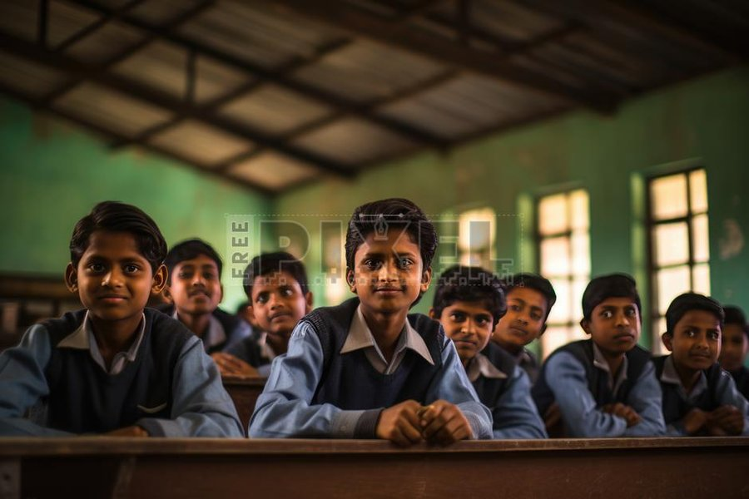
Young students in a classroom, symbolizing the foundation of India's educational system.
Expanding Reach, Lingering Quality Concerns
Enrollment and Attainment
- Approximately 58.29% of individuals aged 15-29 have achieved education up to secondary schooling or beyond.
- Despite this, a notable challenge exists: 25% of youth aged 14-18 struggle to read a Class-2 level text fluently in their regional languages, indicating foundational learning gaps.
- Enrollment in undergraduate studies is significant, with figures around 78.09%, and postgraduate studies at 11.5%, showcasing a strong aspiration for formal education.
The Employability Paradox
A critical issue facing Indian youth is the disconnect between academic qualifications and job readiness. Only about 46% of Indian graduates are considered employable due to skill gaps, particularly in advanced and digital competencies. This highlights a systemic problem where educational institutions may not be adequately equipping students with the practical skills demanded by industries.
- The lack of skills aligned with market demands contributes significantly to youth unemployment.
- Government policies, such as the National Education Policy 2020 (NEP 2020), aim to integrate vocational education and skill development into the curriculum to enhance employability.

Employment: Navigating a Complex Labor Market
The employment landscape for Indian youth is characterized by a mix of opportunities and significant challenges, notably high unemployment rates, particularly among the educated, and a burgeoning informal sector.
Unemployment and Underemployment
The Youth Unemployment Crisis
- Youth unemployment rates for those aged 15-29 hover between 10.2% and 13.8%, significantly higher than the overall national unemployment rate.
- Paradoxically, higher educational attainment is often linked to higher unemployment rates, with graduates facing more difficulty securing suitable employment.
- An estimated 12 million young individuals enter the labor market annually, intensifying competition for limited quality jobs.
The NEET Challenge and Informal Economy
A substantial proportion of young people are classified as NEET (Not in Employment, Education, or Training), with approximately one in every three youngsters falling into this category by 2022. The labor market heavily relies on temporary and low-paying jobs, and the informal sector continues to be a dominant employer. While the gig economy is emerging, women's participation remains low, representing only 20% of India's gig workforce.
This bar chart illustrates key challenges and opportunities for Indian youth, showing areas requiring significant intervention and those with moderate progress. Graduate employability is moderate, while youth unemployment and digital skills gaps are notable concerns.

Digital Literacy: Bridging the Digital Divide
While India has experienced a rapid adoption of technology, particularly with the doubling of smartphone ownership in rural areas to 75% by 2022, significant disparities persist in digital literacy and access to advanced digital skills.
This video highlights India's significant achievement in digital empowerment through the Pradhan Mantri Gramin Digital Saksharta Abhiyan (PMGDISHA) program. It underscores the government's efforts to expand digital literacy to rural populations, a critical step towards bridging the digital divide and enabling greater access to information and opportunities for Indian youth.
Access, Skills, and Policy Initiatives
Uneven Digital Landscape
- Only around 26.8% to 27% of youth in the academic age group possess basic internet browsing skills, indicating a substantial digital skills gap.
- The digital divide is particularly pronounced between urban and rural areas, with less than one-third of individuals aged 15-29 capable of browsing the internet, sending emails, or conducting online transactions effectively.
- Only 32.4% of India's 1.47 million schools are digitally equipped, further exacerbating the disparities.
Government Initiatives
Recognizing the importance of digital literacy, the Indian government has launched various initiatives to address these gaps. Programs like the Digital India Mission, Pradhan Mantri Gramin Digital Saksharta Abhiyan (PMGDISHA), and the National Education Policy (NEP) 2020 are focused on enhancing digital literacy through infrastructure investment, blended learning platforms, and skill development.
- There is a growing emphasis on developing advanced digital competencies in areas such as AI, data analysis, cybersecurity, and blockchain, which are vital for future economic growth.

Social Engagement: A Dynamic and Evolving Role
Indian youth are increasingly active in various social and civic spheres, leveraging digital platforms for engagement and contributing to sustainable development initiatives.
Civic Participation and Entrepreneurship
Digital Activism and Political Engagement
- Approximately 48% of youth aged 18-29 utilize social media platforms for political engagement, demonstrating a growing interest in civic discourse and activism.
- Platforms like YouTube (94% usage among 18-24 year olds) and Twitter (now X, with 45% usage) serve as crucial channels for expression and participation.
- Initiatives like "Khelo India" promote sports and cultural activities, aiming to foster youth skills and provide employment support, reflecting broader efforts to channel youth energy into constructive avenues.
Innovation and Sustainable Development
Youth are actively involved in leading innovations, particularly within the MSME sector, where they drive entrepreneurship and financial literacy. Their adoption of technology is improving business efficiency and market reach, contributing to economic modernization and sustainable business practices. Diaspora networks and civil society initiatives also play a role in channeling youth voices into development and governance conversations.
Indian Youth LandscapeEducation Challenges andOpportunitiesAccess to EducationHigh primary enrollmentRising higher educationGERQuality Concerns25% 14-18 year oldsstruggle with basic reading46% graduates lackemployable skillsPolicy InitiativesNEP 2020 for skillintegrationEmployment RealitiesHigh Youth Unemployment10.2-13.8% for 15-29 agegroupHigher unemployment forgraduatesLabor Market DynamicsDominance of temporary,low-paying jobsLarge NEET population (1 in3 youth)Emerging gig economy (20%female participation)Entrepreneurship & MSMEYouth driving innovation inMSMEFocus on financial literacyDigital Literacy & DivideAccess Statistics75% rural smartphonepenetration (2022)Only 32.4% schools digitallyequippedDigital Skill Gaps~27% youth have internetbrowsing skillsLack of AI, data analysis,cybersecurity skillsGovernment ProgramsDigital India MissionPMGDISHA for rural digitalliteracySocial & Civic ParticipationDigital Presence & PoliticalActivity48% use social media forpolitical engagementYouTube (94%), Twitter(45%)Youth-Focused ProgramsPromoting sports and skillsthrough Khelo IndiaCommunity & DevelopmentYouth innovation in MSMEsectorDiaspora networks and civicinitiatives
This mindmap visually organizes the key aspects of the Indian youth landscape, detailing the opportunities and challenges across education, employment, digital literacy, and social engagement.

Challenges and Opportunities: A Balanced Perspective
The status of Indian youth presents a dual narrative of immense potential tempered by significant systemic challenges. While the demographic dividend offers a unique opportunity for accelerated growth, addressing the underlying issues is paramount.
Addressing Skill Mismatches
The gap between the skills possessed by graduates and those required by the industry remains a primary impediment. This necessitates a radical overhaul of educational curricula to focus on practical, industry-relevant skills, including critical thinking, problem-solving, and advanced digital competencies. Vocational training programs, internships, and apprenticeships can play a crucial role in bridging this divide.
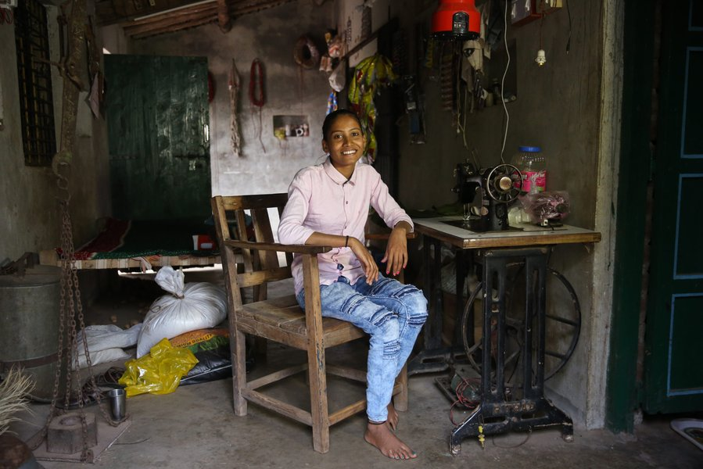
Young individuals engaged in vocational training, symbolizing efforts to bridge the skill gap in India.
Fostering Digital Inclusion
Despite increased access to smartphones, genuine digital literacy—the ability to effectively use digital tools for learning, work, and civic participation—is still nascent for a large segment of the youth. Expanding digital infrastructure, particularly in rural areas, coupled with comprehensive digital education programs, is essential. These programs should move beyond basic internet usage to encompass advanced skills necessary for participation in the digital economy.
Promoting Entrepreneurship and Formal Employment
Given the pressures on formal sector jobs and the prevalence of the informal economy, fostering an ecosystem for youth entrepreneurship is vital. This includes providing access to capital, mentorship, and business development support. Additionally, policies aimed at formalizing the economy and creating more stable, high-quality jobs are crucial for leveraging the youth dividend effectively.
This radar chart illustrates the perceived gap between the current state of Indian youth across key developmental areas and an ideal state where the demographic dividend is fully realized. Areas like Educational Quality, Job Market Alignment, and Digital Proficiency show significant room for improvement, while Social Empowerment and Entrepreneurial Drive demonstrate moderate strengths.

Comparative Overview of Key Indicators
To further illustrate the multifaceted situation of Indian youth, the following table summarizes key statistics across the discussed domains, highlighting both progress and areas requiring urgent attention.
Category | Key Statistic/Trend | Implication
Education Access | ~58.29% youth (15-29) educated up to secondary or beyond | Significant progress in broad educational reach.
Education Quality | 25% youth (14-18) cannot read Class-2 level text fluently | Indicates foundational learning gaps.
Employability | ~46% of graduates considered employable due to skill gaps | Major disconnect between education and market demands.
Youth Unemployment | 10.2% to 13.8% for 15-29 age group | High unemployment, especially among educated youth.
NEET Population | 1 in 3 youth (as of 2022) are NEET | Significant portion disengaged from education, employment, or training.
Rural Smartphone Penetration | Doubled to 75% by 2022 | Increased access to digital tools.
Digital Literacy (Basic) | ~26.8% to 27% youth (academic age) have internet browsing skills | Substantial digital skills gap remains.
Digitally Equipped Schools | Only 32.4% of India's 1.47 million schools | Exacerbates urban-rural digital divide.
Political Engagement (Social Media) | ~48% youth (18-29) use social media for political engagement | High and growing civic participation through digital platforms.
Entrepreneurship | Youth driving innovation in MSME sector | Emerging bright spot for economic modernization.

Frequently Asked Questions
What is the size of India's youth population?
What are the main challenges facing Indian youth in employment?
How digitally literate are Indian youth?
How are Indian youth engaged socially and politically?

Conclusion
The youth of India represent an unparalleled asset, a dynamic force capable of propelling the nation to new heights. While progress has been made in education access and digital adoption, persistent challenges in skill alignment, employment opportunities, and true digital literacy must be addressed with urgency and strategic foresight. By investing in quality education tailored to future demands, fostering an environment conducive to entrepreneurship and formal employment, and ensuring inclusive digital empowerment, India can effectively harness its demographic dividend, transforming potential into prosperity for its vast young population.

